LOAD BALANCER - PATH ROUTING

1) Launch an instance in us-east 1a availability region as ORDERSERVER

Login to the server and install apache and create index.html file in the following path var/www/html. Try to access it in browser.

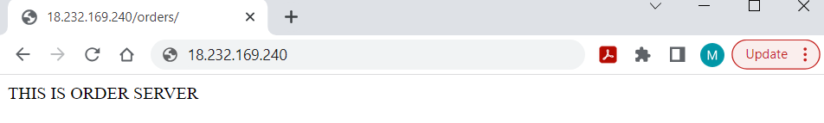

2) Launch an instance in us-east 1b availability region as PAYMENTSERVER.

Login to the server and install apache and create index.html file in the following path var/www/html. Try to access it in browser.

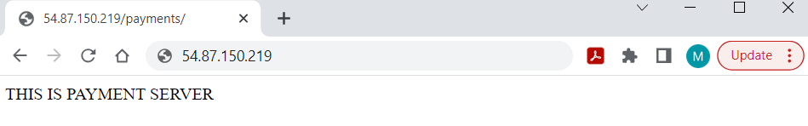

3) Now create target group for this server “ORDERSERVER” as orderapp-TG and in health check provide health check path as /order/index.html .

And associate ORDERSERVER to that target group

4) Now create target group for this server “PAYMENTSERVER” as paymentapplication-TG

and in health check provide health check path as /payments/index.html .

And associate PAYMENTSERVER to that target group

5) Now create load balancer and give name as

payorder-loadbal. And select at-least two availability zones.

In Listener http :80 port 🡪allow orderapp-TG

6) After creating load balancer….add load balancer security group Id to both servers (ORDERSERVER, PAYMENTSERVER).

7) Now try to access the load balancer DNS url



8) Now to go load balancer and set rules by performing below steps

Listener ->http:80 ->rules->manage rules->insert rules

Select ->path ->/order\*

Select ->add action ->forward to -> orderapp-TG

And save it and add another rule

Select ->path ->/payments\*

Select ->add action ->forward to -> paymentapplication-TG

And save it

9) Now access load balancer DNS /orders and check traffic is routing to order server

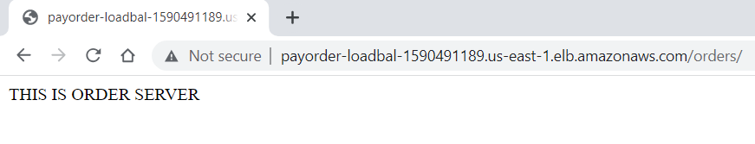

10) Now access load balancer DNS/payments and check traffic is routing to payment server

